Jackson County Department of Public Health
Environmental Health - (828) 587-8250
Temporary Food Establishment Vendor Application
This application is to be completed and submitted to the Jackson County Department of Public Health (JCDPH). A Temporary Food Establishment (TFE) permit is required to sell food or drink at a special event. A separate Event Application shall be submitted by the organizer of the event.
- Vendor applications, TFE Commissary Applications and Event Applications must be submitted 15 days prior to the event and/or commencement of operation at a TFE Commissary or Permitted Establishment
- Applications may be mailed, faxed, or submitted directly to the Environmental Health Office of JCDPH at 154 Medical Park Loop, Sylva, NC 28779
- A fee of $75.00 will be required for each TFE permit and must be paid with the submission of the vendor application
- Food Vendor Applications will not be considered complete until the Organizer Application is received at the JCDPH. If the Organizer Application is not received 15 days prior to the event, the Vendor Application will be denied.
- Name of Event: Click here to enter text.
- Date(s) of Event: Click here to enter text.
- Address of Event: Click here to enter text.
Street, City, State and Zip
- Name of Vendor: Click here to enter text. Vendor Phone: Click here to enter text.
- Vendor Business Address: Click here to enter text.
Street, City, State and Zip
- Applicant Name: Click here to enter text. Applicant Phone: Click here to enter text.
- Applicant E-mail Address: Click here to enter text.
- Requested Date of Permit: Click here to enter text. Requested Time of Permit: Click here to enter text.
**Food booth must be completely set up prior to permitting and NO FOOD PREPARATION is allowed in the booth until the permit is issued. **
- Will vendor prepare food prior to the event? ☐ Yes ☐ No
If you checked “yes” food will be prepared prior to the event, provide the name of the facility where food will be prepared:
Name of Prep Facility: Click here to enter text. Date of Prep: Click here to enter text. Time of Prep: Click here to enter text.
Address of Prep Facility: Click here to enter text.
Street, City, State and Zip
**Advanced Preparation may require a permit or visit by JCDPH for the preparation site.** No Domestic Kitchens can be used for preparation. If using an existing permitted facility, submit a TFE Shared Use Agreement letter with application. If establishment is permitted in another county, include copy of their permit.

- Do you have an approved Employee Health Policy? ☐ Yes ☐ No
- What equipment will you be using in your TFE? Please check appropriate box(s). If you check “other”, please describe in the space provided.
Cold Holding Hot Holding Utensil Washing Hand Washing
For Health Department Use Only
Date Application Received: ________ By: _________
Receipt #: ______________
Date Event Application Received: __________

☐Refrigerated Truck ☐Electric Hot Box ☐3 Utensil Sinks ☐Hand Sink
☐Commercial Refrigerator ☐Grill ☐3 Compartment Sink ☐Free Flow Container
☐Other: Click here to enter text. ☐Other: Click here to enter text. ☐Other: Click here to enter text.
TFE Menu Details
Provide information for all food/menu items in the chart below. If food/menu items will be prepared prior to the event check “Advanced Preparation” or N/A if no advance preparation is needed. If ready-to-eat produce will be prepared in your TFE indicate this in the “Cut, Washed, Assembled” column. If produce is processed on-site, a dedicated vegetable wash preparation sink will be required. Food must be purchased from approved source, have food receipts available for inspection.
*Please note: Food preparation may not exceed more than 7 days prior to the event.
Food/Menu Item | Source/Food Supplier | Advanced Preparation | Cut, Washed, Assembled | Cooking Equipment Procedure | Hot/Cold Holding
Ex. Lettuce | Ingles | N/A | Lettuce Prep On-site | N/A | In Refrigeration
Ex. Burger Patties | Ingles | N/A | N/A | Frozen patty to grill | Crockpot with beef stock
Click here to enter text. | Click here to enter text. | Click here to enter text. | Click here to enter text. | Click here to enter text. | Click here to enter text.
Click here to enter text. | Click here to enter text. | Click here to enter text. | Click here to enter text. | Click here to enter text. | Click here to enter text.
Click here to enter text. | Click here to enter text. | Click here to enter text. | Click here to enter text. | Click here to enter text. | Click here to enter text.
Click here to enter text. | Click here to enter text. | Click here to enter text. | Click here to enter text. | Click here to enter text. | Click here to enter text.
Click here to enter text. | Click here to enter text. | Click here to enter text. | Click here to enter text. | Click here to enter text. | Click here to enter text.
Click here to enter text. | Click here to enter text. | Click here to enter text. | Click here to enter text. | Click here to enter text. | Click here to enter text.
Click here to enter text. | Click here to enter text. | Click here to enter text. | Click here to enter text. | Click here to enter text. | Click here to enter text.
Click here to enter text. | Click here to enter text. | Click here to enter text. | Click here to enter text. | Click here to enter text. | Click here to enter text.
Click here to enter text. | Click here to enter text. | Click here to enter text. | Click here to enter text. | Click here to enter text. | Click here to enter text.
Click here to enter text. | Click here to enter text. | Click here to enter text. | Click here to enter text. | Click here to enter text. | Click here to enter text.
Click here to enter text. | Click here to enter text. | Click here to enter text. | Click here to enter text. | Click here to enter text. | Click here to enter text.
Click here to enter text. | Click here to enter text. | Click here to enter text. | Click here to enter text. | Click here to enter text. | Click here to enter text.

- What will be your source of water for your food booth? Please check the appropriate box(s). If you check “Other”, please describe in the space provided.
☐Public water supplied by the organizer (requires food grade hose)
☐On-site private well (requires sampling by JCDPH prior to event)
☐Bottled water
☐Other: Click here to enter text.
NOTE: All potable water holding tanks, containers, and hoses used to transport or store water at the TFE shall be drained, washed, rinsed and sanitized. Containers and hoses used to store, haul, or convey water shall be approved for potable water use, shall not be used for any other purpose, and shall be protected from contamination. Warm water shall be available and used for cleaning.

- How will you dispose of waste generated at your TFE? Please check the appropriate box(s). If you check “other”, please describe in the space provided.
Wastewater Disposal Garbage Disposal Grease Disposal
☐Provided by the event ☐Provided by the event ☐Provided by the event
☐Taken off-site ☐Taken off-site ☐Taken off-site
☐Other: Click here to enter text. ☐Other: Click here to enter text. ☐Other: Click here to enter text.
- Check the box that best describes your TFE booth set-up. If you checked “Other”, please describe in the space provided.
☐3-Sided Tent ☐Mobile Food Unit ☐Tent with Fans ☐Other: Click here to enter text.

- Find the following example of a typical food booth and hand washing station set-up. All food booths must have approved hand wash set-up and utensil washing set-up stations. Other equipment needs may vary.
3 Sided 10’x20’ Tent Buckets for Catching Wastewater

Coolers
Burners

Grill
Table for
Dry
Storage

Produce Washing Sink

Table Space
for Air-Drying
3 Basins for Utensil Washing/Rinsing/Sanitizing
Warm Water and Test Strips

Chest Freezer
Table for Public Barrier Cashier‘s Area

Container for free flow water for hand washing. Paper towels and soap

Hot Holding and Storage Table

- Equipment Layout Diagram:
Please provide a layout of your proposed set-up including all equipment used for cooking, hot holding, cold holding, hand washing station, work tables, utensil washing station, etc...

I hereby certify that the information submitted on the application is correct, and I understand that any deviations from the above without prior consultation with JCDPH may nullify final approval and prevent a permit from being issued. I agree that I have received the Checklist for Temporary Food Establishment Vendors and Handwashing Guide form and will meet all applicable requirements.

Applicant Signature: ________________________________________ Date: ________________________
Health Department Use Only
Review Signature: _______________________________________ Date: ________________
Comments: ____________________________________________________________________________________________________________________________________________________________________________________________________________________________________________________________________________________________________________________________________________________________________________________________________________________________________________________________________________________________________________________________________________________________________________________________________________________________________________________________________________________________________________

Jackson County Department of Public Health
Environmental Health – (828) 587-8250
Checklist for Temporary Food Establishment Vendors
(Keep page 5 & 6 for your records)
The following is a checklist to assist a vendor in setting up a Temporary Food Establishment (TFE). All items on the checklist are necessary to obtain for a TFE; however, additional requirements may be applicable. All applications must be submitted to Jackson County Department of Public Health (JCDPH) at least 15 days prior to the date of the event.
You may obtain a copy of the Rules Governing the Sanitation of Restaurants and Other Food-handling Establishments and the North Carolina Food Code at https://ehs.ncpublichealth.com/rules.htm.
**Food booth must be completely set up prior to permitting and NO FOOD PREPARATION is allowed in the booth until the permit is issued. **
**Advanced Preparation may require a permit by JCDPH for the preparation site.** No Domestic Kitchens can be used for preparation. Preparing food prior to the event without JCDPH approval may result in discarding of food.

**If using an existing permitted establishment for preparing food, obtaining ice or water, wastewater disposal, storage, etc., provide a TFE Shared Use Agreement letter with the application signed by the establishment indicating space that will be used, time(s) space will be used and any service at facility. If establishment is permitted in another county, include copy of the permit.

Person in charge
- Available during all hours of food preparation
Employee requirements
- Gloves
- Employee Health Policy Agreement
- Hat, hair net or visor
Tent/weather proof structure/canopy
- Canopy over entire operation (smokers are not required to be under a canopy)
Fly protection
- 3 solid or mesh sides
- Fly fans
Ground covering
- Protection from dust/mud (in the absence of asphalt, concrete or grass)
Water supply
- Approved water source (requires testing by JCDPH if private well)
- Drinking water hose(s) – must be labeled
- A means to heat water
Waste water disposal
- Buckets/grey water containers – must be labeled
- Disposal in approved sewage system

- 3 basins (large enough to fit equipment)
- Drain board or counter space for air drying
- Soapy water, rinse water, sanitizer
- Sanitizer test strips
Hand washing station
- At least 2 gallons of hot water under pressure
- Free-flowing faucet/stop cock
- Soap and disposable towels
- Wastewater catch bucket – must be labeled
Approved/protected/secured food
- Approved source/food invoices
- Food storage above ground
- Separate vegetable washing sink (when preparing/serving ready-to-eat vegetables)
Food temperatures
- Accurate food thermometer
- Cold holding: refrigeration/freezer/coolers with ice (drain plug)
- Hot holding equipment
Food shields/customer barriers
- No food exposed to customers
- Approved self-service condiments
Lighting (for night-time operations)
- Shielded above food/preparation

Handwashing Guide
Hand Sanitizer is not a suitable replacement for appropriate handwashing!
Guide to Setting up A Temporary Handwash Station:

Trash Can with a Lid
Discard Bucket to Catch Water
Continuous Flow Spigot
Water Container with Warm Water
Paper Towels
Soap
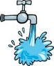
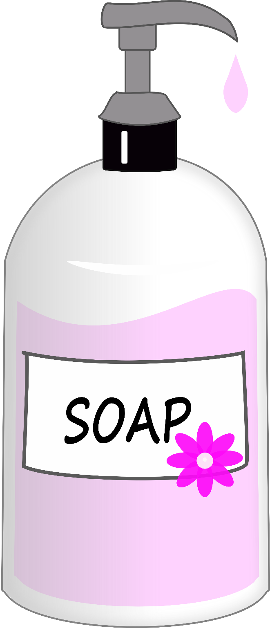

Items Needed:
- Warm water for hand washing delivered through a continuous flow-spout. No push-button spouts are permitted.
- A container to hold wastewater, which must be disposed into an approved wastewater system.
- Soap (hand sanitizer is not a replacement for hand washing).
- Single use paper towels.
Why is Washing Important?
Keeping hands clean through improved hand hygiene is one of the most important steps we can take to avoid getting sick and spreading germs to others. Many diseases and conditions are spread by not washing hands with soap and clean, running water.
Correct Handwashing Procedures
- Wet your hands with warm running water.
- Apply soap.
- Vigorously scrub hands and arms for at least 15 seconds. Clean under fingernails, between fingers, wrists, and back of hands.
- Rinse thoroughly under running water. Do not turn off the water faucet yet.
- Dry hands and arms with a single-use paper towel. After drying hands, use the paper towel to turn off the water faucet. Throw paper towel away.

