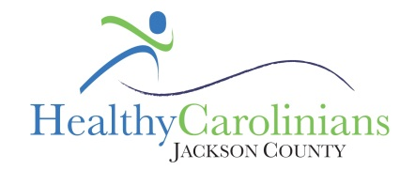
Healthy Carolinians of Jackson County
Current Action Team Highlights- 2015

Healthy Eating Action Team
- Community Garden promotion
- Healthy Snack Masters Competition completed
  - 13 recipes submitted; 5 participated; 1 individual winner and 1 group winner
- 5-2-1-Almost None campaign
  - Message shared on 2 websites and with the school system
- Food of the Month campaign
  - 6 press releases; 12 community event; and 3 cooking demonstration
- Taste of Sylva
  - 28 art entries; 5 restaurants/businesses participated

Active for Life Action Team
- Various exercise programs
  - Arthritis Foundation Exercise Program w/1193 participants
  - Walk with Ease w/423 participants
  - Tai Chi for Arthritis w/525 participants
- Stroke Screening with Harris Regional Hospital
  - 38 people participated
- 5th Annual Healthy Living Festival held in May 2014:
  - 35 exhibitors and 113 attendees
- Jackson County Get Fit Challenge:
  - Countywide fitness challenge
  - 5 rounds completed
  - Over 539 participants and 73 teams

Substance Abuse Action Team
- Prevention Services
- Implementation of Project Lazarus grant
  - Reorganized SAAT coalition
  - Participated in 1 Take Back event
  - Promoted Project Lazarus model through community education and prevention
    - Attended community events, distributed lock boxes, distributed pieces of literature and t-shirts, and promoted through 12 newspaper ads

